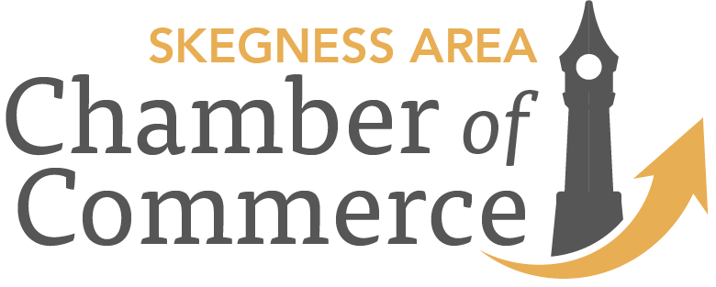

Skegness Business Awards 2018
Best New Business Award - sponsored by Duncan & Toplis

How to Enter this category
Are you a new business trading in and around the Skegness area? This category aims to raise the profile of new businesses and give them the boost that any new enterprise will value. Entries can be made in two ways 1) You can nominate yourself or 2) ask someone else to nominate you. Either can be done on this entry form.
If you are nominating someone else please provide details that will enable us to contact the business. We will want to be in touch with them to ask for information about the business and their services that will help the shortlisting judges. If you are the business owner and wish to nominate yourself you can start by providing these details. We have posed some questions to assist you to focus on the principal areas that the judges will be assessing. You are of course free to add further information that will support your application.
The judges will identify three finalists from the written submissions. Applicants will be advised if they have been successful as soon as possible after the closing date and a judges visit will be arranged with the three finalists. The visit will enable the judges to determine their winner. Each finalist will receive a certificate and 2 complimentary tickets to the Awards Ceremony on 30th November 2018 at Southview where the winner will be announced.
The closing date for entries is 25th September 2018. Submit 1) online, email info@skegnessbusinessawards.co.uk 2) post Fix Auto Skegness, Grantham Drive PE25 3RN

Best New Business
Business Name
Contact Name
Business Address
Contact tel no
Contact email
Website address
Name and contact details of person nominating.
Please answer the following questions so that our judges can gain the best insight into your new business and its qualities and why you believe it should be shortlisted.
- When did your business start, who operates it, what are the key products /services offered.

- What are the challenges and opportunities and how are you responding to them.

- What are your aspirations for the future.

Judging Criteria

Category – Best New Business

Awards Overview
This award is for a new business which will have started in the Skegness area within the last three years. The business may have been conceived and developed elsewhere but the first operation in Skegness must be within the three years.

Main Judging Criteria
Judges will be looking for businesses that have spotted and seized an opportunity to offer goods or services to Skegness and or further afield. They will be looking for innovation, skill and commitment and an effective governance that will set the business up for long term success.

Evidence Requirements
A business plan that has been implemented and can be explained in clear unambiguous language.
Details of a challenge that has been overcome.
Details of an opportunity that is being exploited.
A clear description of hopes and ambitions for the future development of the business.

